AUTOMOBILE DASHBOARD ANALYSIS

By

Sachin Gunjal

Power BI Project

**Requirements: Excel, SQL, Power BI, DAX, Data Visualization, Ms Word**

# INTRODUCTION

Describe the project here. What will students do? What will students learn? How will students present their project?

# Standards:

* List learning and content standards here
* List learning and content standards here
* List learning and content standards here

# Objectives:

* List objectives here
* List objectives here
* List objectives here

# Requirements/Task(s):

**Task-1**

1. **How can you calculate the total sales for each year using DAX?**

Total Sales = SUM(Automobile[SalePrice])

1. **Create a measure to calculate the average sales per month.**

Average Sales Per month =

AVERAGEX(

    VALUES('Date Table'[MonthName]),

    [Total Sales]

)

1. **How would you create a cumulative total of sales over months?**

Cumulative sales over month = CALCULATE(

                            [Total Sales],

                            FILTER(ALLSELECTED('Date Table'[Date]), 'Date Table'[Date] <= MAX('Date Table'[Date])

                            )

)

1. **Write a DAX formula to calculate the Year-to-Date (YTD) sales.**

YTD Sales = TOTALYTD([Total Sales], 'Date Table'[Date])

1. **How can you calculate the percentage growth in sales compared to the previous year?**

YoY Sales Growth % = DIVIDE([Total Sales] - CALCULATE([Total Sales], DATEADD('Date Table'[Date], -1, YEAR)),

                                            CALCULATE([Total Sales], DATEADD('Date Table'[Date], -1, YEAR)))

1. **Create a measure to calculate the total sales for the last 12 months.**

Last 12 Months Sale = CALCULATE([Total Sales],

DATESINPERIOD('Date Table'[Date], Max('Date Table'[Date]), -12,Month))

1. **How would you calculate the highest sales month using DAX?**

Highest Sales Month = MAXX(SUMMARIZE(Date, Date[Month], "Sales", [Total Sales]), [Sales])

1. **Write a DAX formula to find the top 5 selling products.**

1. **How can you calculate the sales contribution of each product category?**

Sales % by Category = DIVIDE([Total Sales], CALCULATE([Total Sales], ALL(Automobile[Manufacturer])))

1. **Create a measure to find the total sales where the sales amount is greater than a specific value.**

Total sales price-over 10k = CALCULATE([Total Sales],   
 Automobile[SalePrice] > 10000)

1. **How can you calculate the running total of sales for each product?**

Running Total of sale = CALCULATE([Total Sales],

                                FILTER(ALLSELECTED('Date Table'[Date]), 'Date Table'[Date] <= MAX('Date Table'[Date]))

)

1. **Write a DAX formula to calculate the average sales per customer.**

Average Sale Per Customer = DIVIDE([Total Sales], DISTINCTCOUNT(Automobile[ClientName]))

1. **How would you calculate the total number of distinct customers?**

Distinct Customers =

DISTINCTCOUNT ( Fact_Sales[ClientName] )

1. **Create a measure to calculate the sales per region.**

Sales Per Country = SUMX( VALUES(Automobile[Country]), [Total Sales])

1. **How can you calculate the moving average of sales over 3 months?**

3 months moving average = AVERAGEX(DATESINPERIOD('Date Table'[Date], max('Date Table'[Date]), -3, MONTH), [Total Sales])

1. **Write a DAX formula to filter sales data for a specific product category/model**

Sales by model = CALCULATE([Total Sales],

FILTER(Automobile, Automobile[Manufacturer] = "Jaguar"))

1. **How can you calculate the sales variance compared to the budget?**
2. **Create a measure to calculate the total profit margin.**

Total Profit Margin = [Total Profit]/[Total Sales]

1. **How would you calculate the sales rank of each product?**

Rank by model = RANKX(ALL(Automobile[Model]), [Total Sales],  ,DESC)

**20. Write a DAX formula to calculate the total sales for a specific date range**.

Total sales in 2013 & 2015 = CALCULATE([Total Sales], DATESBETWEEN('Date Table'[Date], DATE(2013,01,01), DATE(2015,12,31)))

**Task 2**

**1.How do you filter the data to show only records where the Make is "Jaguar"?**

JaguarMaker = CALCULATE([Total Sales], FILTER(Automobile, Automobile[Manufacturer] = "Jaguar"))

**2. How can you remove the columns ClientName and LaborCost from the dataset?**

We can directly remove or hide columns from dataset. If we are using these columns for calculating any other measure/calculated column then we can hide it or no use, delete from model from Data pane/table view/model view.

**3. How can you replace the values "Coupe" with "Convertible" in the VehicleType column?**

* Go to Home → Transform Data.
* In the Power Query editor, select the column VehicleType.
* Right-click → Replace Values.
* Enter Coupe as the value to find and Convertible as the replacement.
* Click OK, and Power BI will update all "Coupe" entries to "Convertible".

OR

We Can use calculated column

**UpdatedVehicleType = IF ( Automobile[VehicleType] = "Coupe", "Convertible", Automobile[VehicleType] )**

**4. How can you add a new column that calculates the total cost (CostPrice + DeliveryCharge + SpareParts + LaborCost) for each record?**

We can add these values in query editor or can use calculated columns by adding it directly.

TotalCost = Automobile[CostPrice] + Automobile[DeliveryCharges] + Automobile[SpareParts] + Automobile[LaborCost]

**5. How can you split the InvoiceDate column into two separate columns: InvoiceYear and InvoiceMonth?**

We can add these values in query editor or can use calculated columns by adding it directly.

It is good to perform these changes from query editor, so report performance gets improve.

Form report view, we can use Year and month function and From query editor, directly add year & month column from date menu.

**6. How can you group the data by Make and CountryName to get the sum of SalePrice for each group?**

**New Table:**

TotalSalesTable =

SUMMARIZE (

Automobile,

Automobile[Country],

Automobile[Manufacturer],

"Total SalesPrice", SUM ( Automobile[SalePrice] )

)

**7. How can you sort the data by SalePrice in descending order?**

Table View -> Click on dropdown and select “Sort Descending”

**8. How can you merge this dataset with another table that contains additional ClientName information, using ClientName as the key?**

* Load both datasets into Power BI.
* Go to Transform Data → Power Query.
* Select your main dataset (Automobile).
* Click Home → Merge Queries.
* In the merge dialog:
* Select the ClientName column in Automobile.
* Select the ClientName column in the second table.
* Choose Inner Join (only matching rows), or Left Join (keep all Automobile rows and match if available).
* After merging, expand the new column to bring in additional client info.

**9. How can you remove duplicate records based on the combination of InvoiceDate and Make?**

* Load your dataset into Power BI → Transform Data.
* In Power Query, select both columns:
* InvoiceDate
* Make
* Go to Home → Remove Rows → Remove Duplicates.

**10. How can you pivot the Color column so that each unique color becomes a new column and the values are the SalePrice?**

* Load the dataset → go to Transform Data.
* Select the Color column.
* Go to the ribbon: Transform → Pivot Column.
* In the dialog:

Values Column = SalePrice.

Aggregate Function = Sum (or Average, depending on what you want).

* Each unique Color will now become its own column with aggregated SalePrice

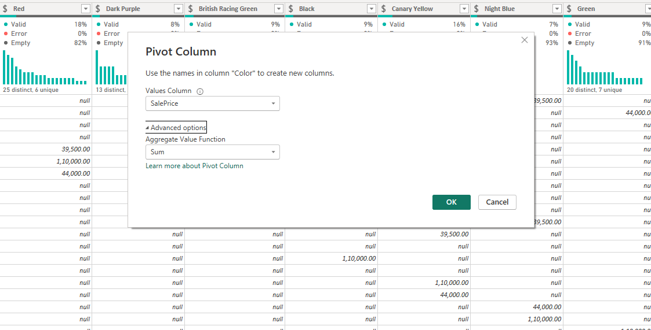

**Task 3**

**1. How can you create a bar chart to compare total sales by product category?**

**2. What steps would you take to create a line chart showing monthly sales trends?**

**3. How can you use a pie chart to show the sales distribution by region?**

**4. Create a scatter plot to visualize the relationship between sales and profit.**

**5. How can you add a trend line to a line chart to show sales growth over time?**

**6. What is the process to create a stacked bar chart to show sales by product category and region?**

**7. How can you use a map visualization to display sales data by geographic location?**

**8. Create a heat map to show the intensity of sales across different regions.**

**9. How can you use a tree map to visualize the sales contribution of each product category?**

**10. What steps would you take to create a waterfall chart to show sales variances?**

**11. How can you create a KPI visual to display key sales metrics?**

**12. What is the process to create a funnel chart to visualize the sales pipeline?**

**13. How can you use a gauge chart to show the performance against a sales target?**

**14. Create a histogram to show the distribution of sales amounts.**

**15. How can you use slicers to filter visualizations based on product categories?**

**16. What steps would you take to create a combo chart to compare sales and profit?**

**17. How can you use a card visual to display the total sales amount? 18. Create a bullet chart to compare actual sales against a target.**

**19. How can you use bookmarks to create a storytelling experience in Power BI?**

**20. What is the process to create a matrix visual to display sales data in a tabular format?**

# Record your notes/research here:

This is where students can record their ideas and research as they gather the information needed to complete their project.

# Outline the steps/plan for your project:

After students complete any research necessary, this is where they will create a plan for their project. Consider requiring teacher approval before they continue to the creation/implementation phase of the project.

## Teacher initials ____________

### You are ready to create your project! Please revisit the project tasks/requirements as you work.

# Summarize what you learned:

Possible student prompts: What did you learn? What worked well? What was the most challenging aspect of this project? What will you do differently next time?

# Add the link to your project here:

Link to access project